Project
  - Deadline: Monday 09/08/2026 @ 23:59
[Total Mark is 20]

Introduction to Database
CS350
Instructions:
- You must submit two separate copies (one Word file and one PDF file) using the Assignment Template on Blackboard via the allocated folder. These files must not be in compressed format.
- It is your responsibility to check and make sure that you have uploaded both the correct files.
- Zero mark will be given if you try to bypass the SafeAssign (e.g. misspell words, remove spaces between words, hide characters, use different character sets, convert text into image or languages other than English or any kind of manipulation).
- Email submission will not be accepted.
- You are advised to make your work clear and well-presented. This includes filling your information on the cover page.
- You must use this template, failing which will result in zero mark.
- You MUST show all your work, and text must not be converted into an image, unless specified otherwise by the question.
- Late submission will result in ZERO mark.
- The work should be your own, copying from students or other resources will result in ZERO mark.
- Use Times New Roman font for all your answers.
Student Details: CRN:50241
Name: Nawaf Kamal Allahyani  Name: Abdulellah Khalid Alali  Name: MOHAMMED ALSHAMMASI  Name: Abdulwahid Alqatari |  | ID: 240006019  ID: 240059980  ID: 240050332  ID: 240045553

Project Instructions
- You can work on this project as a group (minimum 3 and maximum 4 students). Each group member must submit the project individually with all group member names mentioned on the cover page.
- This project worth 20 marks and will be distributed as in the following:
  - Database Design. (6 marks)
  - Database Implementation. (6 marks)
  - SQL Operations. (6 marks)
  - Project Reflection. (2 marks)
- Each leader in the group must submit one report about their chosen Project via the Blackboard (Email submission will not be accepted and will be awarded ZERO marks) containing the following:
- Task 1 : database design
- Task 2: database implementation
- All requested queries/results
- Screenshots from MySQL (or any other software you use) of all the tables after population and query results.
- Reflection (300–500 words) describing the team's experience, challenges, design decisions, and AI usage (if applicable).
- Submit one SQL file containing the complete database implementation, including database creation, tables, data insertion, required queries, VIEW, and TRIGGER.
- Submit a GitHub (or GitLab) repository containing the complete project with regular commits and meaningful commit messages.
- Submit a progress report describing the completed work, key decisions, challenges, future plan, and contribution of each group member.
- Include links to the live report document, GitHub/GitLab repository, and Google Colab notebook (if applicable) in the Project Artifacts section of the final report.
- You are advised to make your work clear and well presented; marks may be reduced for poor presentation. This includes filling in your information on the cover page.
- You MUST show all your work, and text must not be converted into an image unless specified otherwise by the question.
- Late submission will result in ZERO marks being awarded.
- The work should be your own. Copying from students or other resources, including AI software, will result in ZERO marks.

Project Description
Design and Implementation of a Smart Clinic Database System
Learning Outcome(s):

CLO1, CLO2, CLO3, CLO4, CLO5

A private clinic currently manages its patient information manually, making it difficult to organize appointments, treatments, and payments. The clinic has decided to develop a database system to improve data organization and retrieval.
Your team is required to design, implement, and test a complete relational database using the concepts learned throughout this course. The project should demonstrate your understanding of database design, ER/EER modeling, relational mapping, SQL implementation, and advanced SQL queries. The project must be completed using MySQL.

Task 1 – Database Design (6 Marks)
- Design a complete database for the clinic that includes at least six entities such as Patients, Doctors, Appointments, Treatments, Medicines, Payments, or any other appropriate entities.
- A complete ER/EER diagram.
- Primary and foreign keys.
- Appropriate relationships with cardinality.
- At least one specialization/generalization (EER feature).
- Any assumptions made during the design process.

Entities are:
- Patient.
- Department.
- Employee (Supertype).
- Doctor (Subtype).
- Nurse (Subtype).
- Pharmacist (Subtype).
- Staff (Subtype).
- Room.
- Appointment.
- Treatment.
- Prescription.
- Medicine.
- Payment.

Entities and their attributes:
Entity | Attributes | Primary Key (PK) | Foreign Key (FK)
Patient | PatientID, FirstName, LastName, DateOfBirth, Gender, Phone, Email, Address, BloodType, EmergencyContact | PatientID
Department | DepartmentID, DepartmentName, Location, PhoneExtension | DepartmentID
Employee (Supertype) | EmployeeID, DepartmentID, FirstName, LastName, Gender, DateOfBirth, Phone, Email, HireDate, Salary | EmployeeID | DepartmentID (DepartmentID)
Doctor (Subtype) | EmployeeID, RoomID, LicenseNumber, Qualification, Specialty, ConsultationFee | Doctor.EmployeeID | EmployeeID (Employee)  RoomID (Room)
Nurse (Subtype) | EmployeeID, RoomID, Qualification, Shift, | Nurse.EmployeeID | EmployeeID (Employee)  RoomID (Room)
Pharmacist (Subtype) | EmployeeID, RoomID, LicenseNumber, Qualification, | Pharmacist.EmployeeID | EmployeeID (Employee)  RoomID (Room)
Staff (Subtype) | EmployeeID, RoomID, JobTitle. | Staff.EmployeeID | EmployeeID (Employee)  RoomID (Room)
Room | RoomID, DepartmentID, RoomNumber, RoomType, Floor | RoomID | DepartmentID (Department)
Appointment | AppointmentID, PatientID, DoctorID, AppointmentDate, AppointmentTime, Status, Reason | AppointmentID | PatientID (PatientID).  DoctorID (Doctor.EmployeeID).
Treatment | TreatmentID, AppointmentID, TreatmentName, Diagnosis, Notes | TreatmentID | AppointmentID (Appointment).
Prescription | PrescriptionID, TreatmentID, MedicineID, Dosage, Duration | PrescriptionID | TreatmentID (Treatment). MedicineID (Medicine).
Medicine | MedicineID, MedicineName, Category, UnitPrice, StockQuantity, ExpiryDate | MedicineID
Payment | PaymentID, AppointmentID, Amount, PaymentDate, PaymentMethod, PaymentStatus | PaymentID | AppointmentID (Appointment).

Relationships and Cardinality:
The first entity | Relationship | The second entity | Cardinality
Department | Employs | Employee | 1 : M
Department | Contain | Room | 1 : M
Employee | ISA | Doctor (Specialization) | 1 : 1
Employee | ISA | Nurse (Specialization) | 1 : 1
Employee | ISA | Pharmacist (Specialization) | 1 : 1
Employee | ISA | Staff (Specialization) | 1 : 1
Room | HAS | Doctor | 1 : 1
Room | HAS | Nurse | 1 : 1
Room | HAS | Pharmacist | 1 : 1
Room | HAS | Staff | 1 : 1
Patient | Books | Appointment | 1 : M
Doctor | Responsible for | Appointment | 1 : M
Appointment | Results In | Treatment | 1 : M
Treatment | Includes | Prescription | 1 : M
Medicine | References | Prescription | 1 : M
Appointment | Generates | Payment | 1 : 1

Specialization:
The database we designed use Specialization (ISA) to model different employee roles. It is Total and Disjoint specialization.

Supertype: Employee.
The Employee supertype stores the common information shared by all clinic
employees, which are:
EmployeeID, DepartmentID, FirstName, LastName, Gender, DateOfBirth, Phone, Email, HireDate, Salary.

Subtypes: Doctor, Nurse, Pharmacist and staff.

- Doctor has these additional attributes:
RoomID, LicenseNumber, Qualification, Specialty, ConsultationFee.

- Nurse has these additional attributes:
RoomID, Shift, Qualification.

- Pharmacist has these additional attributes:
RoomID, LicenseNumber, Qualification.

- Staff has this additional attribute:
RoomID, JobTitle.

This specialization removes duplicate employee data while permitting each
staff position to preserve its unique characteristics.

Assumptions:
- Each patient is uniquely identified by a PatientID.
- Each employee belongs to exactly one specific department.
- Employees mapped under the Doctor subtype can be assigned to conduct patient appointments.
- A patient can book and have multiple appointments over time.
- A doctor can be responsible for and conduct multiple appointments.
- One single appointment can result in or include multiple individual treatments.: One medical treatment sequence can generate multiple separate prescriptions.
- Each prescription record references exactly one single medicine code.
- One specific medicine from the inventory can appear across many different patient prescriptions.
- Every individual appointment generates exactly one corresponding payment record.
- Medicines are strictly tracked in a centralized pharmacy inventory table before being mapped to active patient prescriptions.
- Each doctor, nurse, pharmacist, or staff member must be linked to exactly one record in the Employee supertype table, and no single employee can hold more than one specific role simultaneously (Total and Disjoint).

ER diagram:
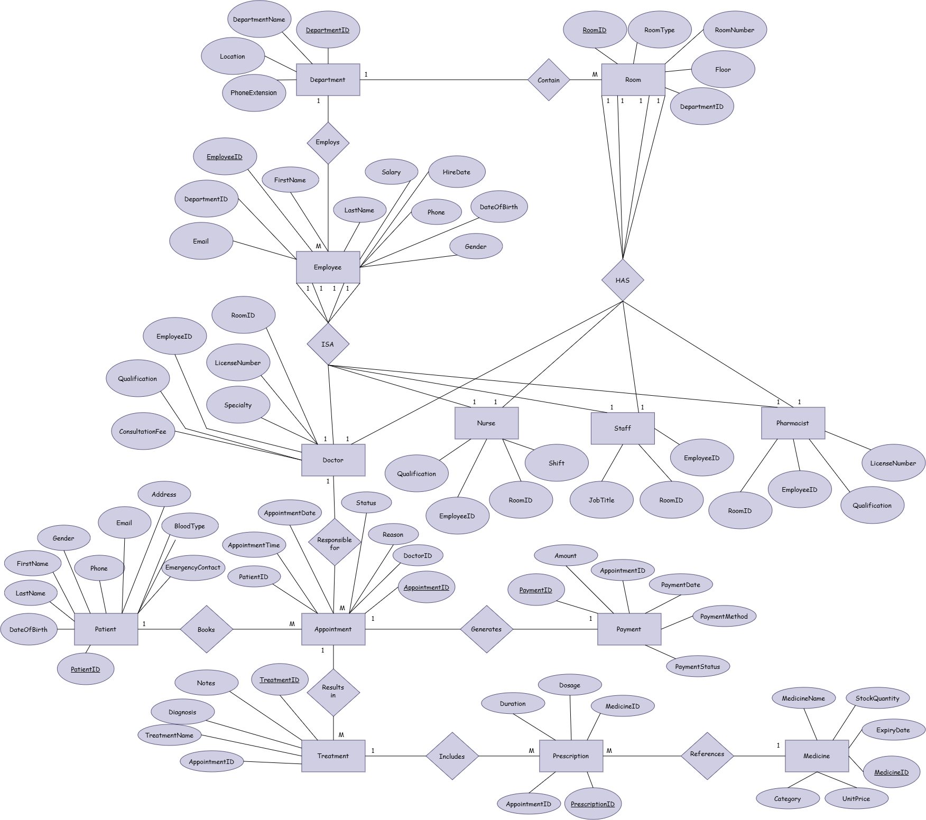

Task 2 – Database Implementation (6 Marks)
Complete the following tasks using MySQL. Include screenshots of both your SQL code and the corresponding output (results) for each task:
- Create the database and all required tables.
- Use appropriate data types and constraints (PRIMARY KEY, FOREIGN KEY, NOT NULL, UNIQUE, etc.).
- Insert at least 5 records into each main table.

These screenshots show the process of creating our Database with the tables (include the code and the output):
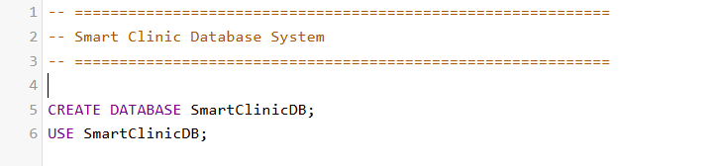

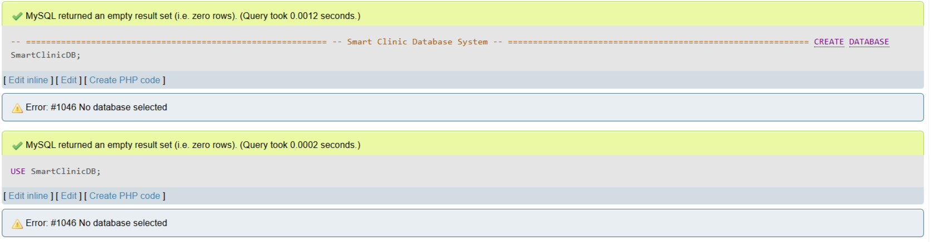

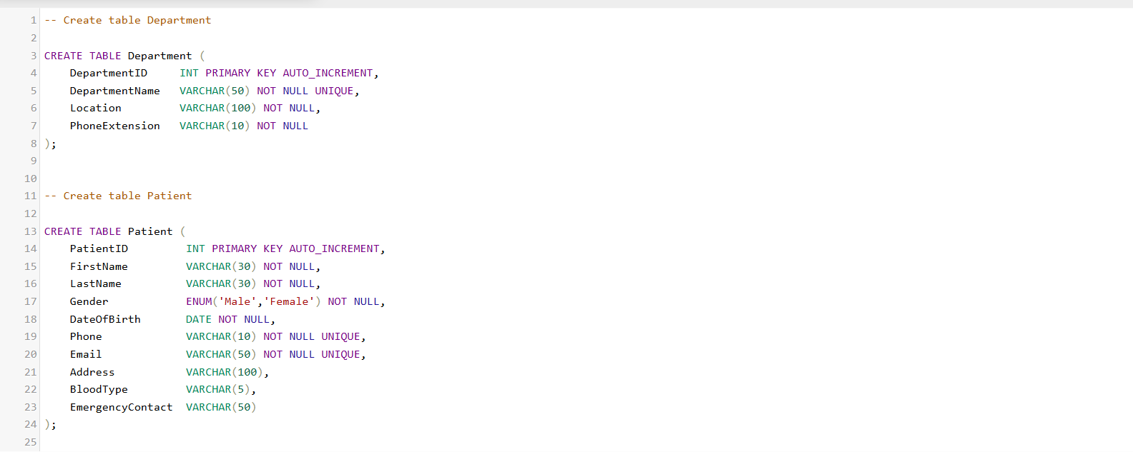

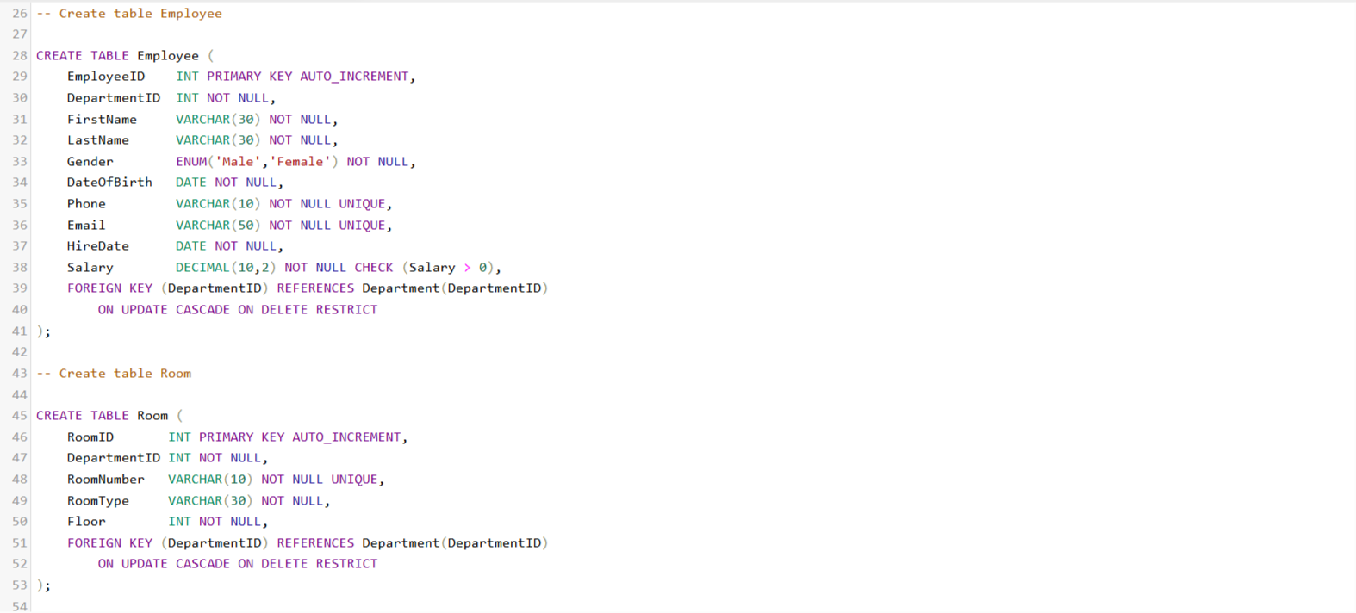

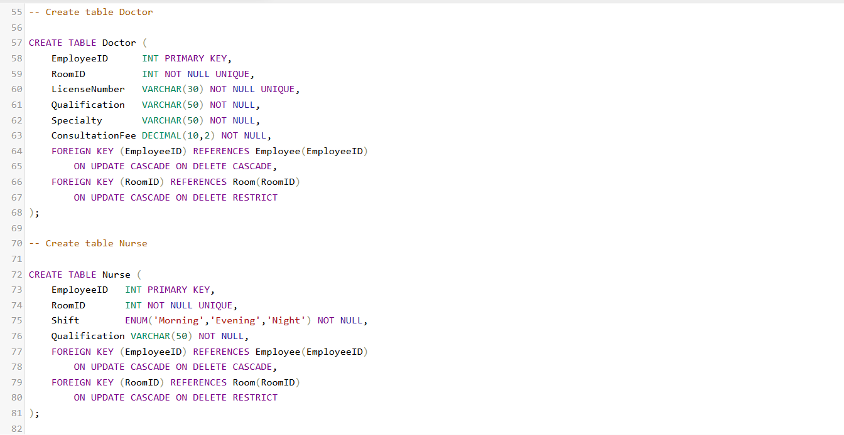

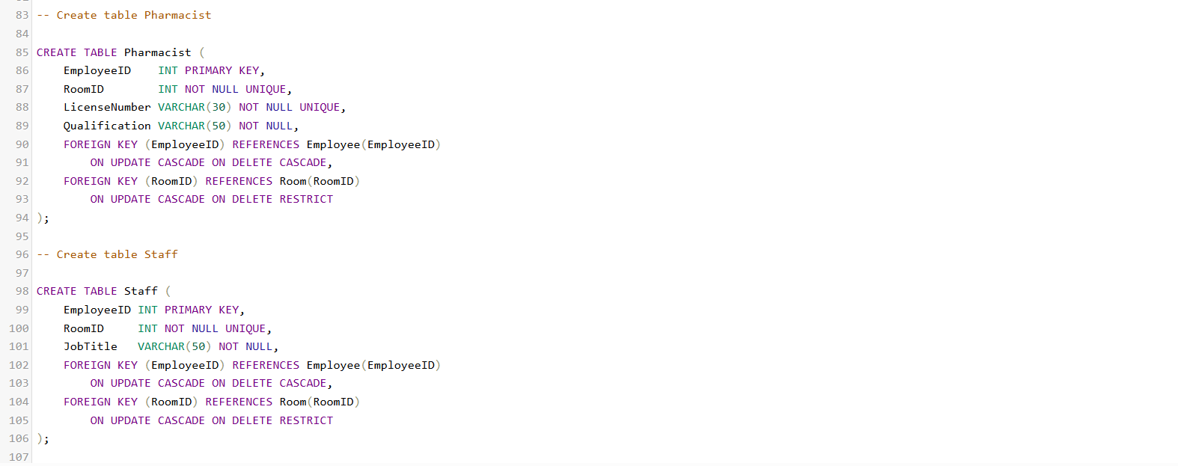

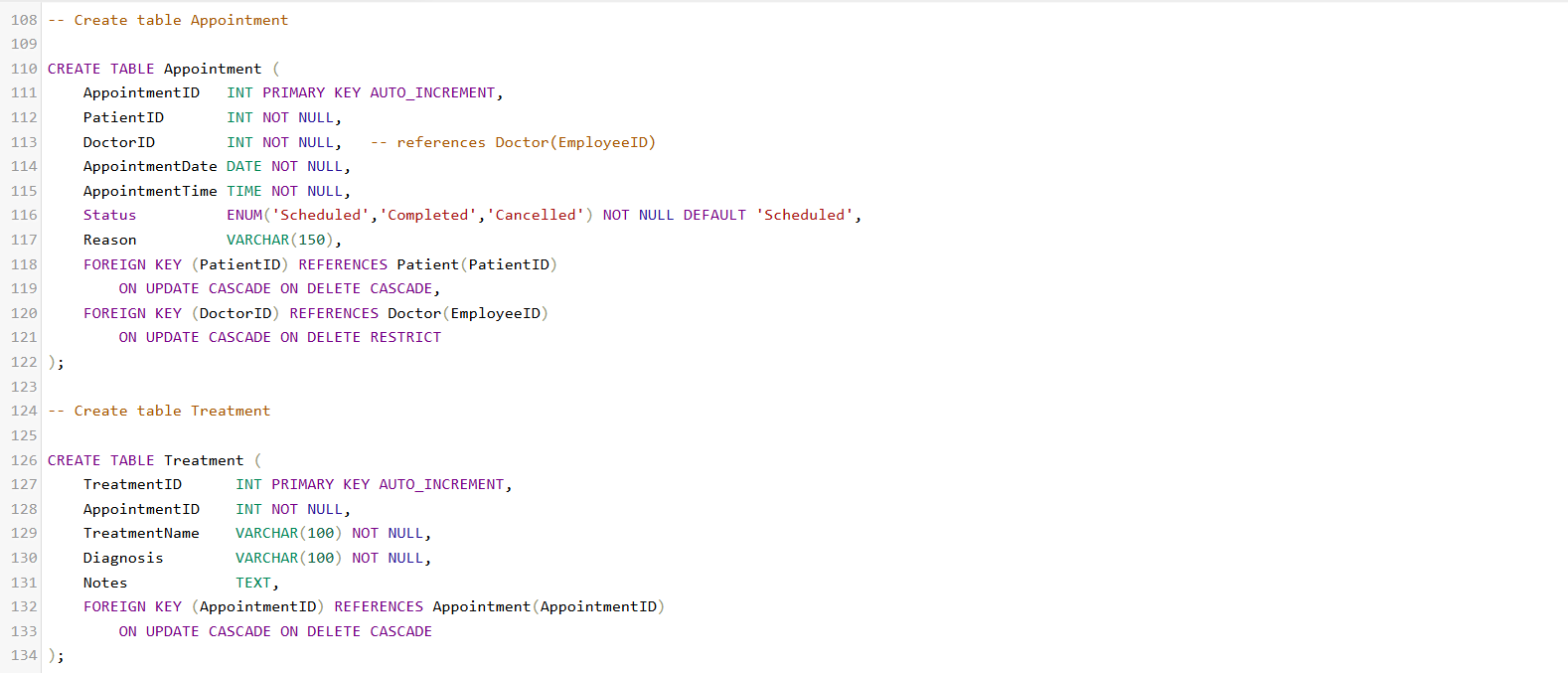

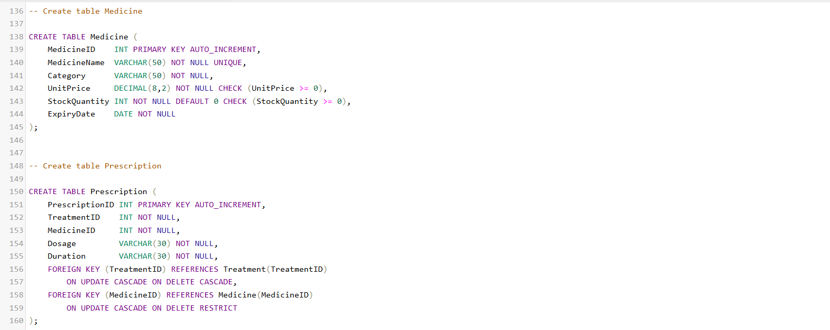

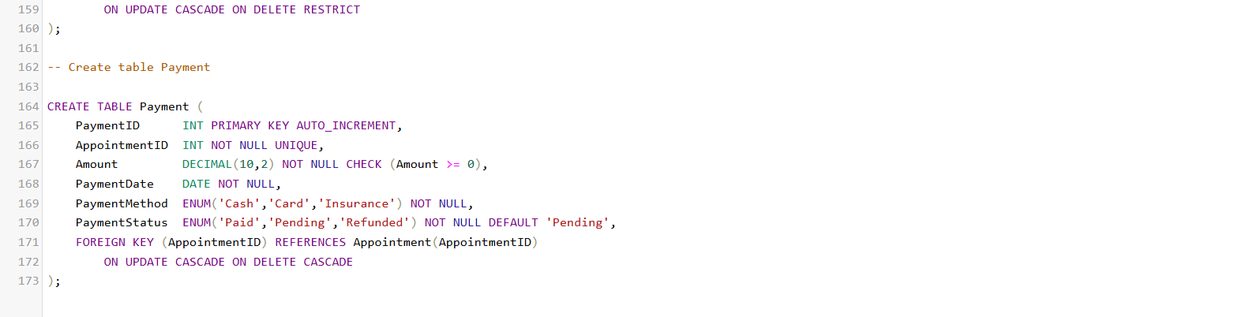

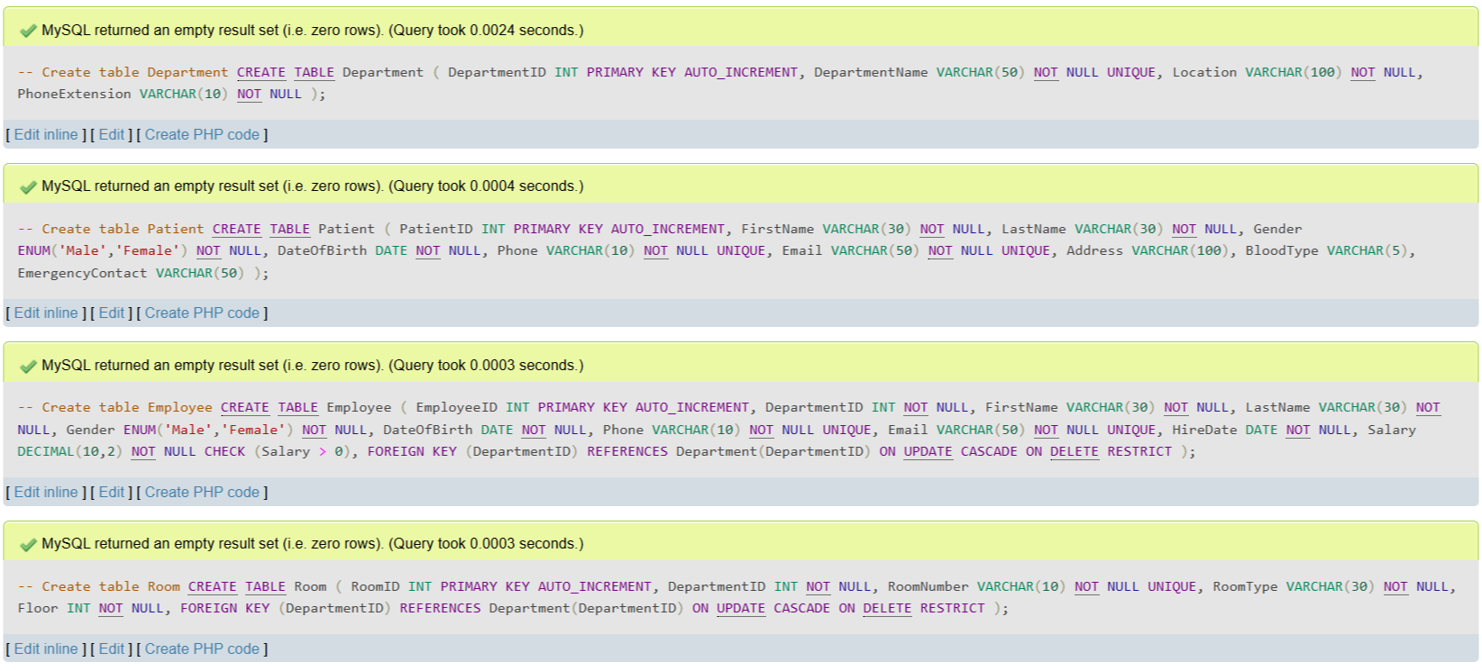
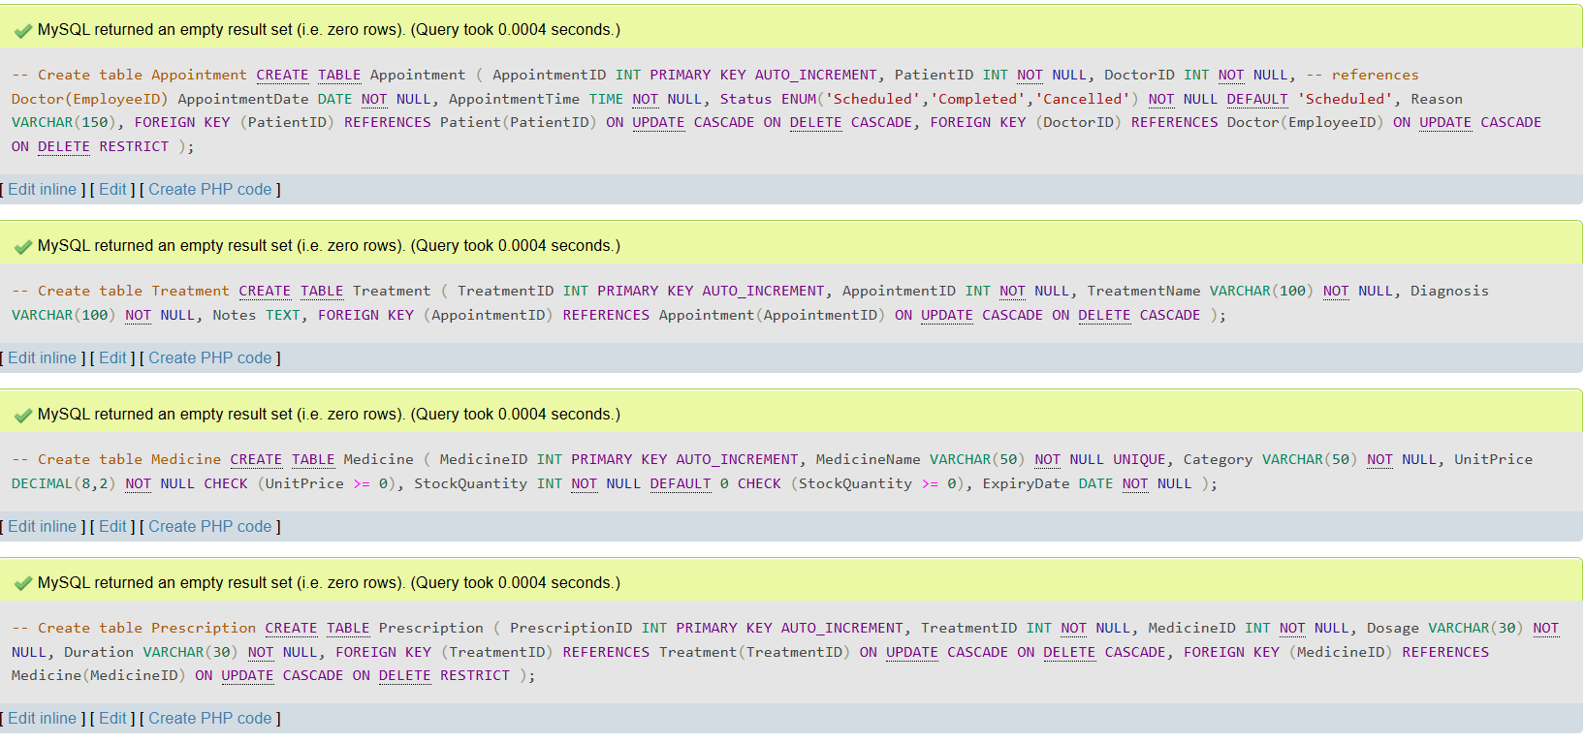
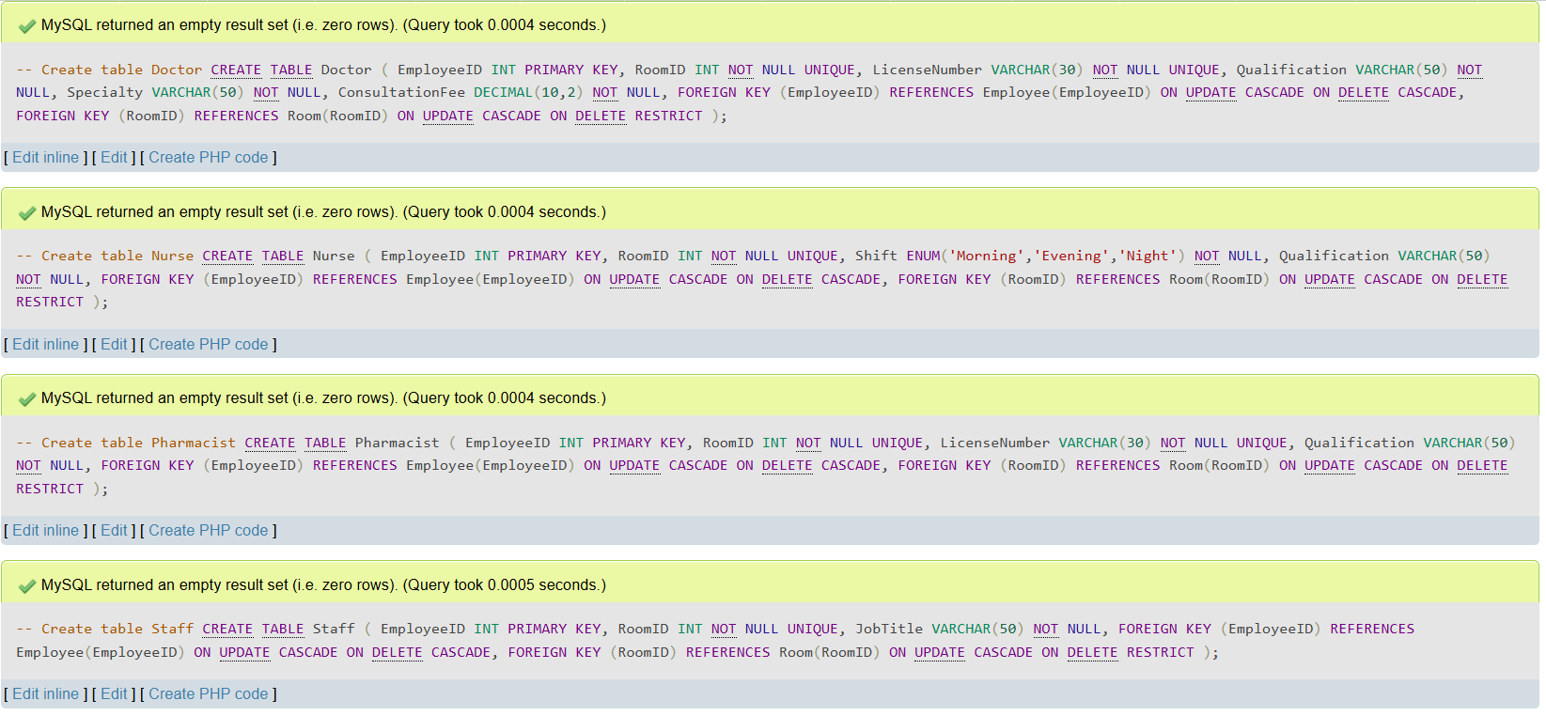
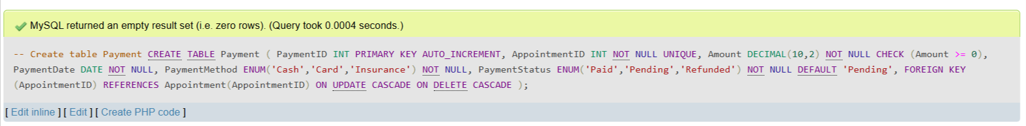
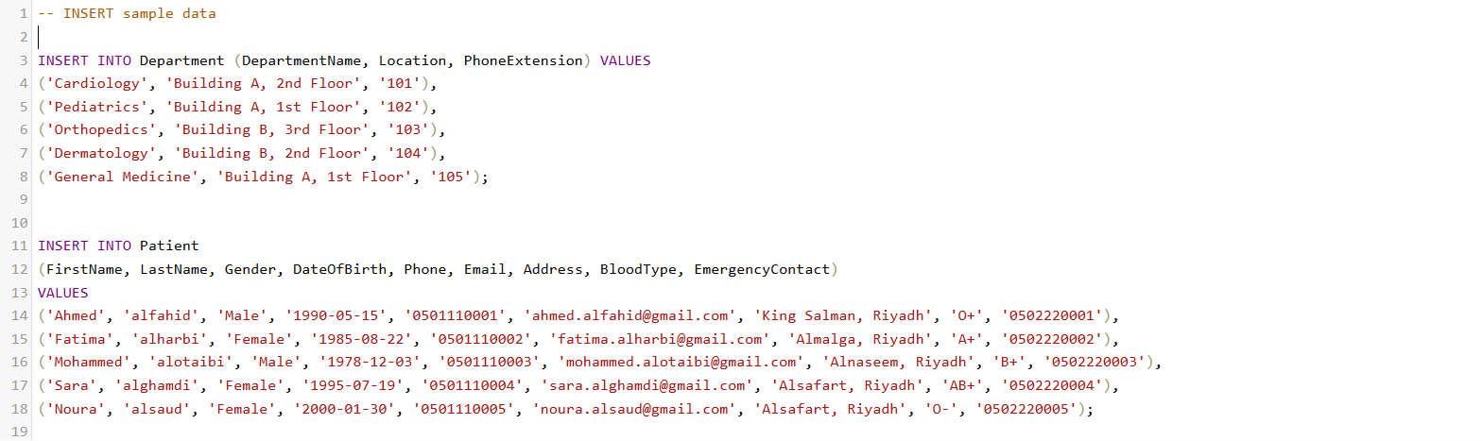
INSERT sample data into tables:

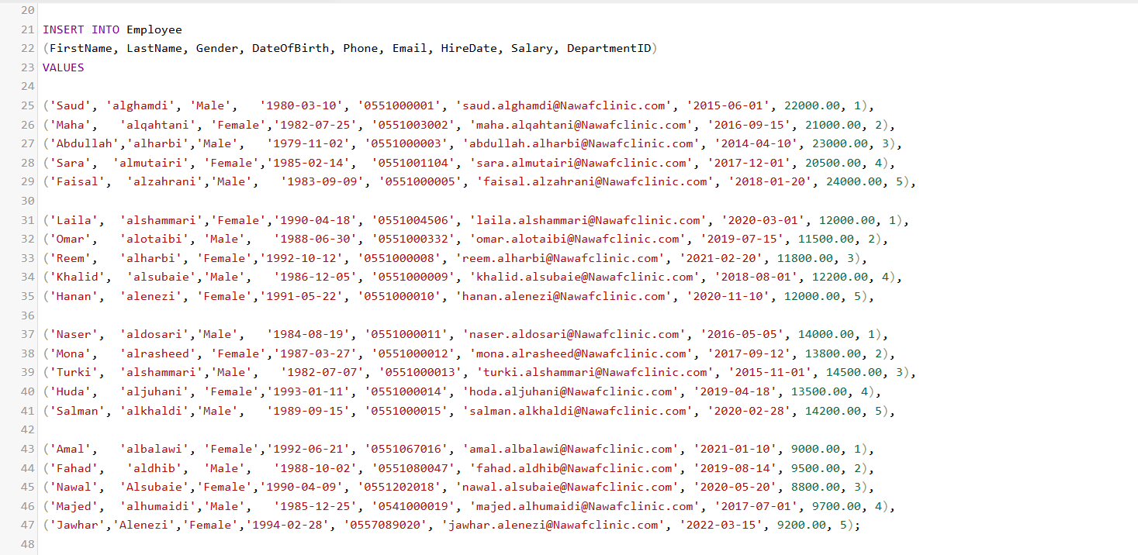

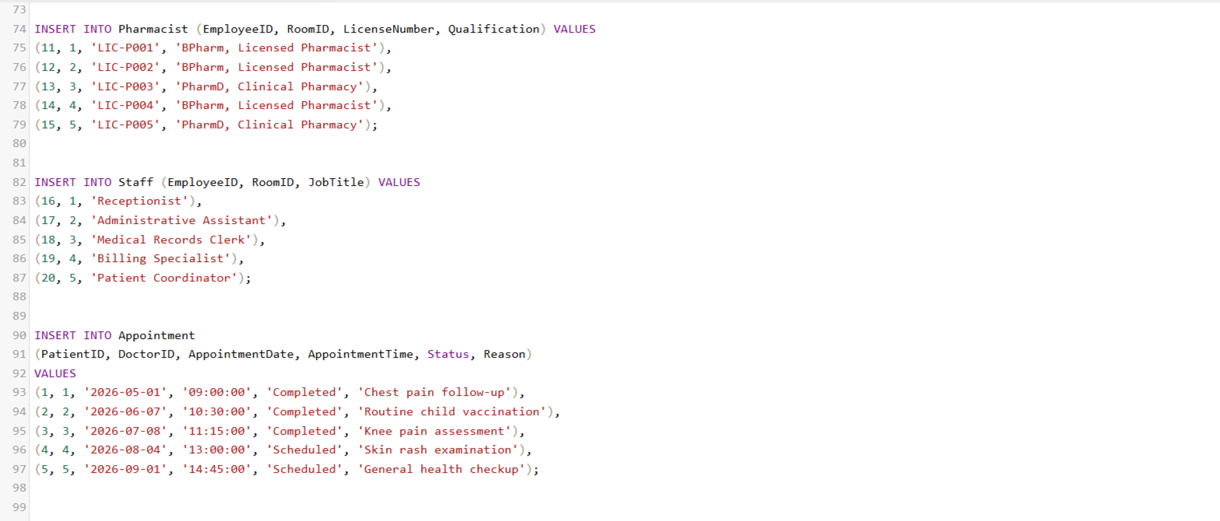

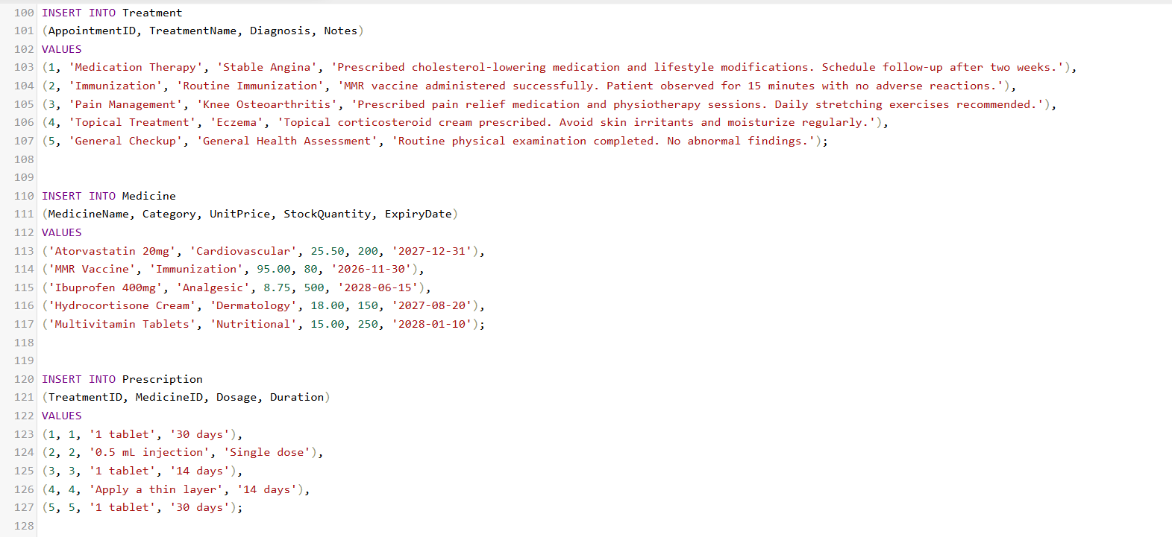

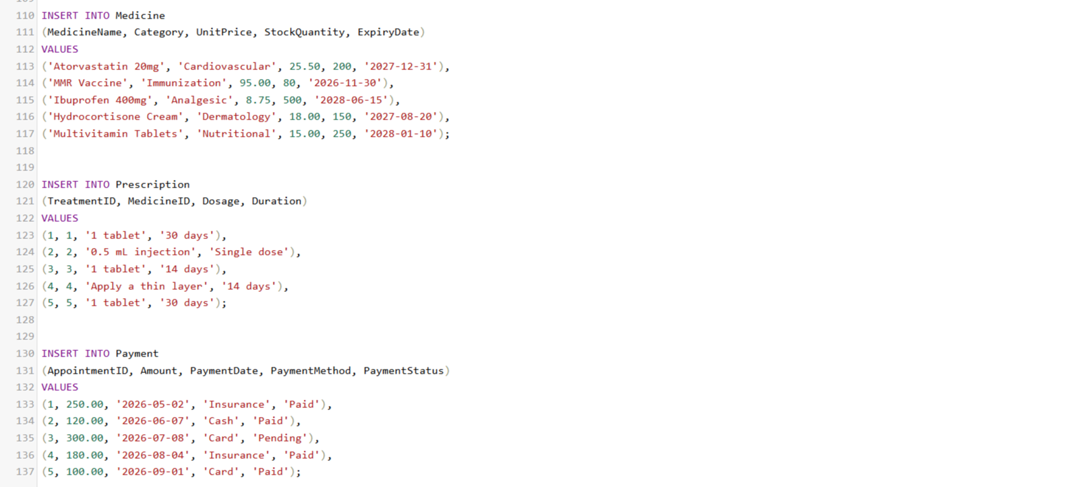

Note: all the code provided with this file.

Task 3 – SQL Operations (6 Marks)
Complete the following tasks using MySQL. For each task, include screenshots of both your SQL code and the corresponding output (results), along with a brief description (one to two sentences) explaining the purpose of the query and the information it is intended to retrieve.
- Write SELECT statements.
- Write JOIN queries.
- Write nested queries.
- Use aggregate functions with GROUP BY.
- Write UPDATE and DELETE statements.
- Create one VIEW.
- Create one TRIGGER.

SELECT statements:
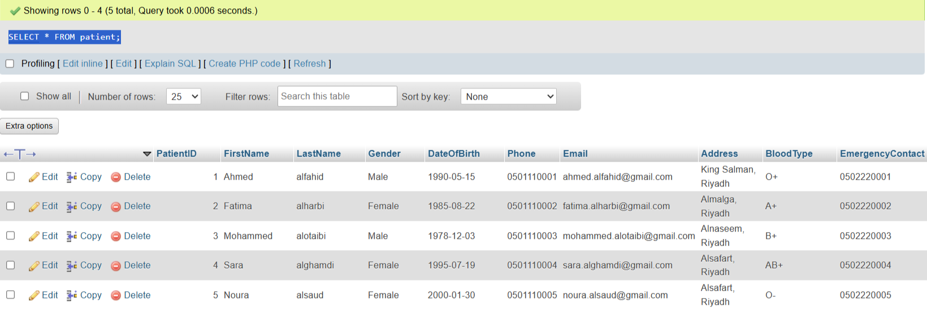

This query retrieves all records from the Patient table. It is used to display complete
patient information stored in the database.

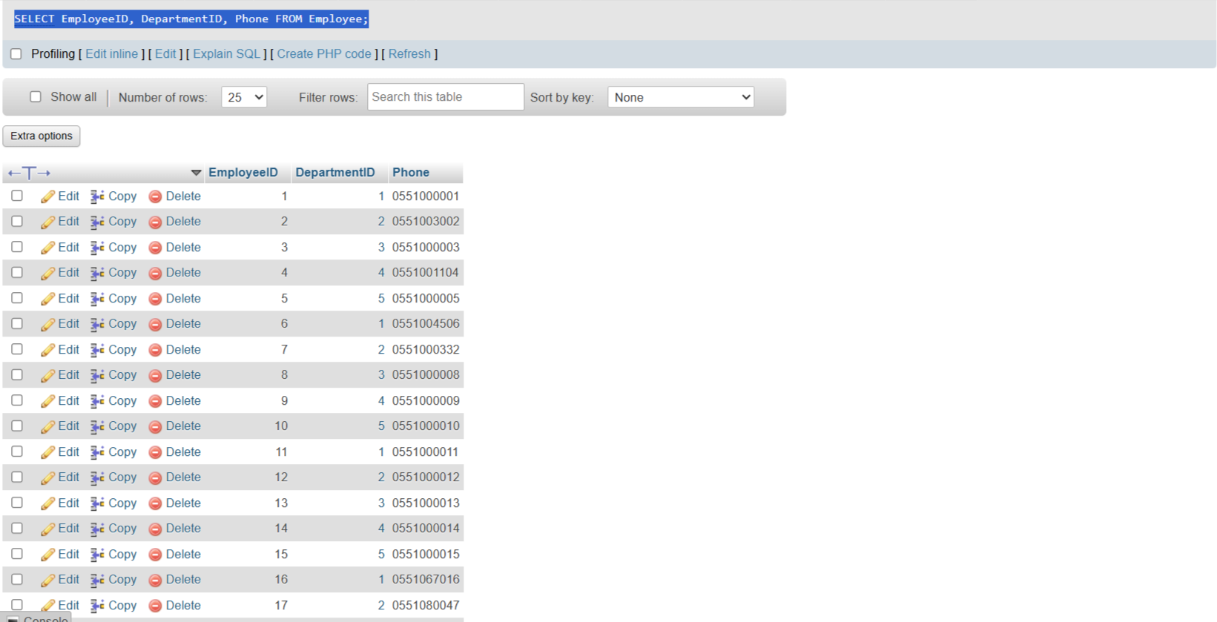

This query retrieves (EmployeeID, DepartmentID, Phone) records from the employee table. It is used to display some employee information stored in the database.
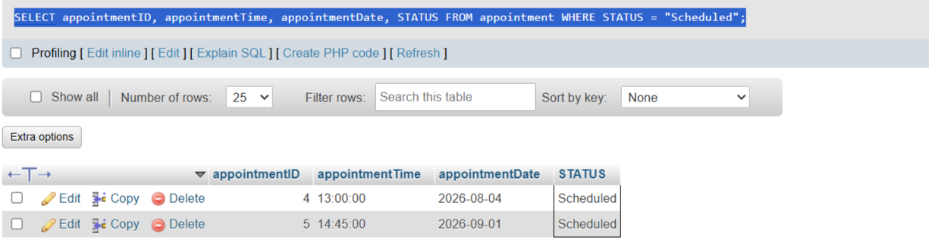

This query retrieves appointments that are currently scheduled. It helps identify upcoming patient appointments.
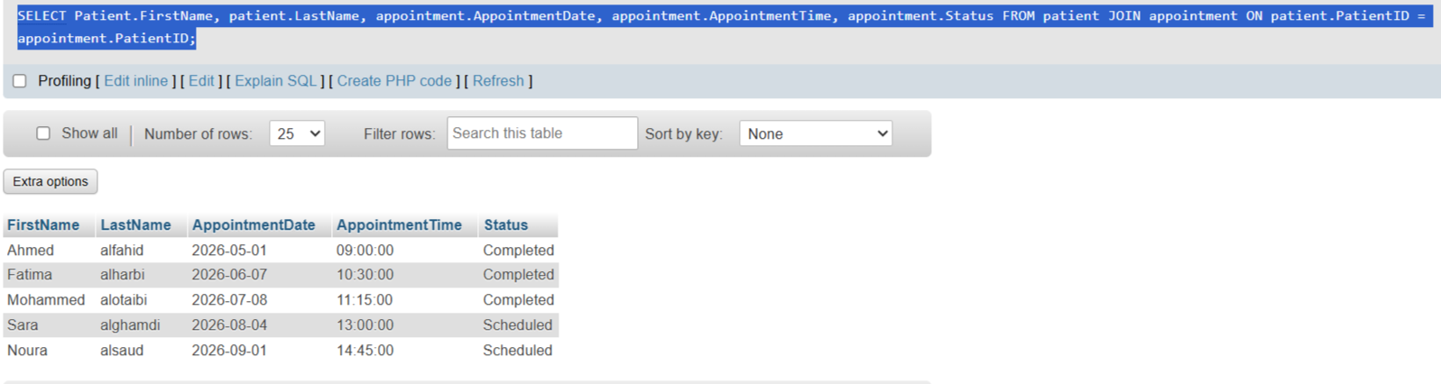
JOIN queries:

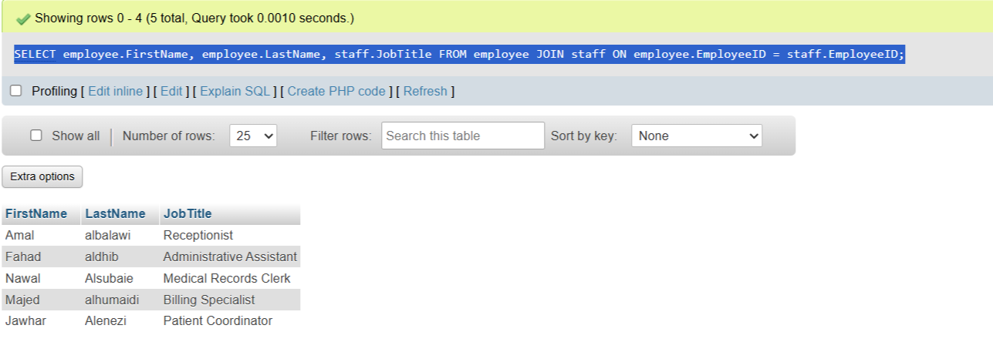
This query joins the Patient and Appointment tables to display each patient's appointment date and appointment status.

This query joins the Employee and Staff tables to display staff' names along with
their JobTitle.

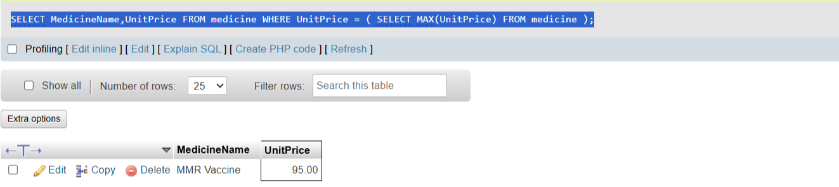
Nested queries:

This nested query retrieves the medicine with the highest unit price.
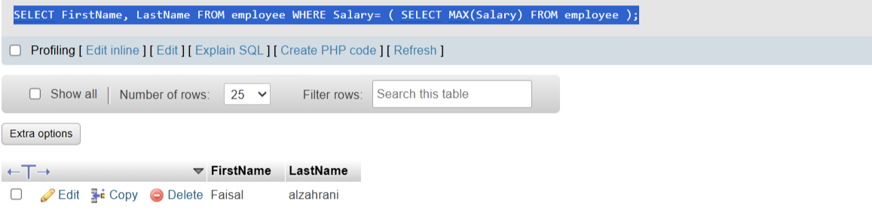

This nested query retrieves the employee with the highest salary.

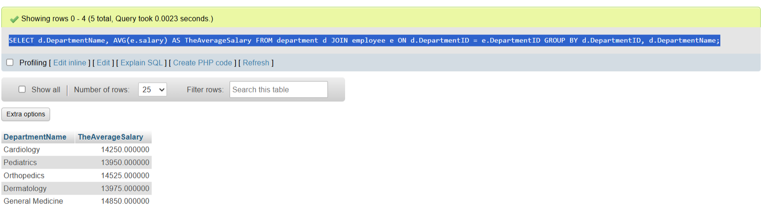
Aggregate functions with GROUP BY:

This query groups employees by department and calculates the average salary in each department. It helps management analyze staffing levels and salary distribution across departments.
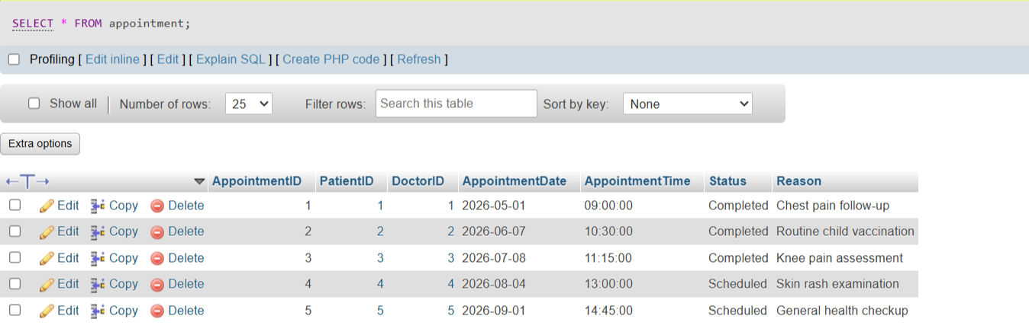
UPDATE statement:

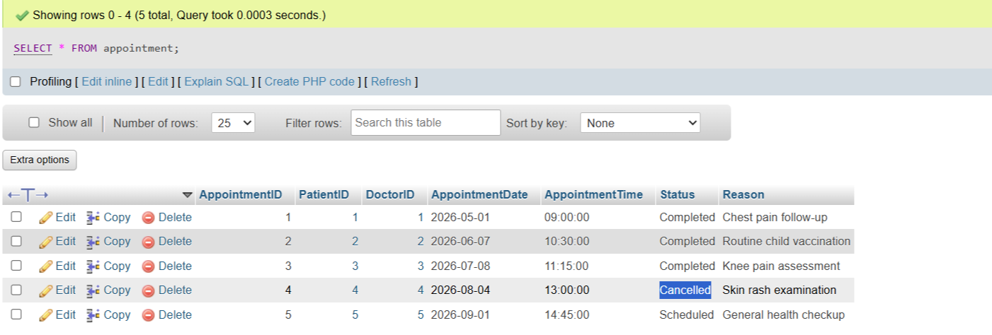

This query updates the status of Appointment 4 from Scheduled to Cancelled after the patient cancel. The SELECT statement verifies that the update was applied successfully.

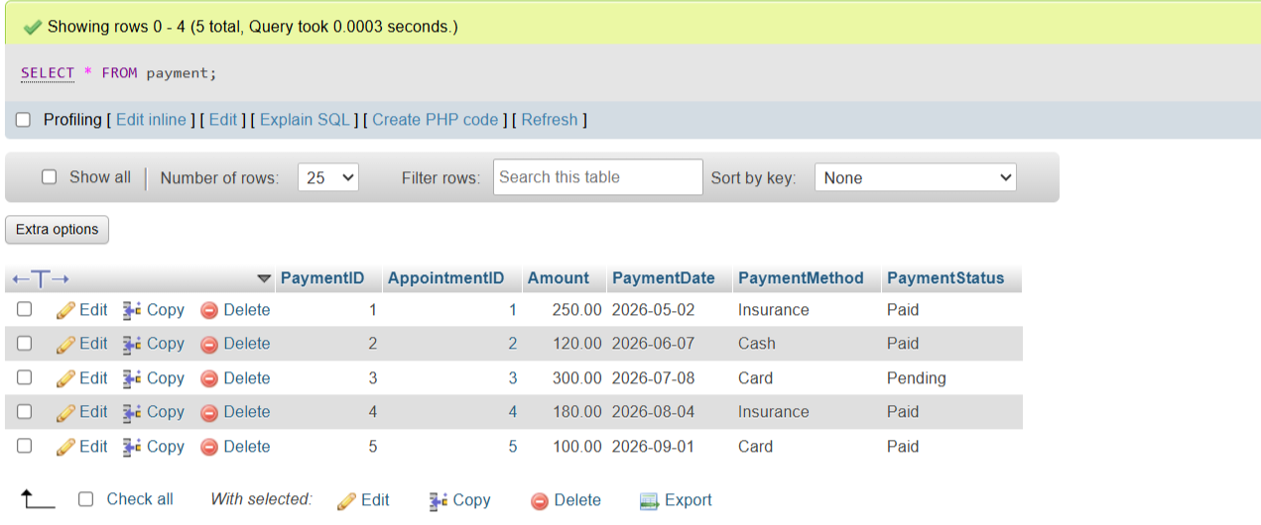
DELETE statement:

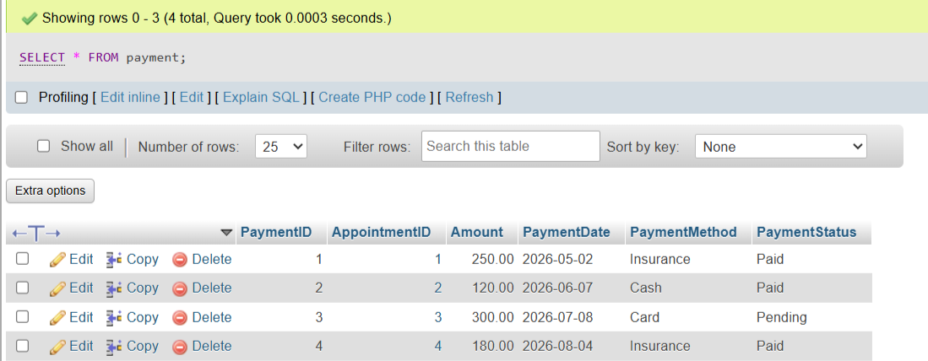

This query removes an incorrect payment record from the Payment table. The SELECT statement confirms that the record has been deleted.

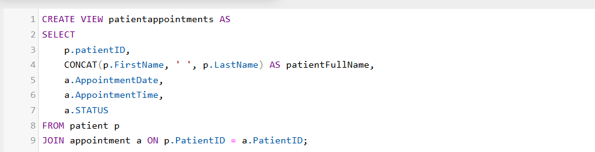
VIEW:

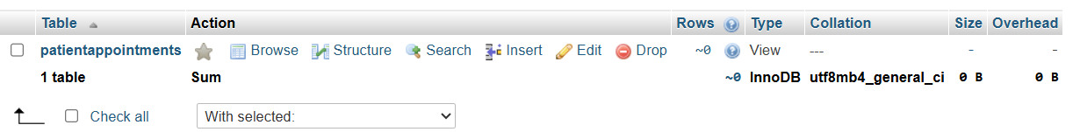

This view combines patient information with appointment details, making it faster to retrieve appointment schedules.

TRIGGER:
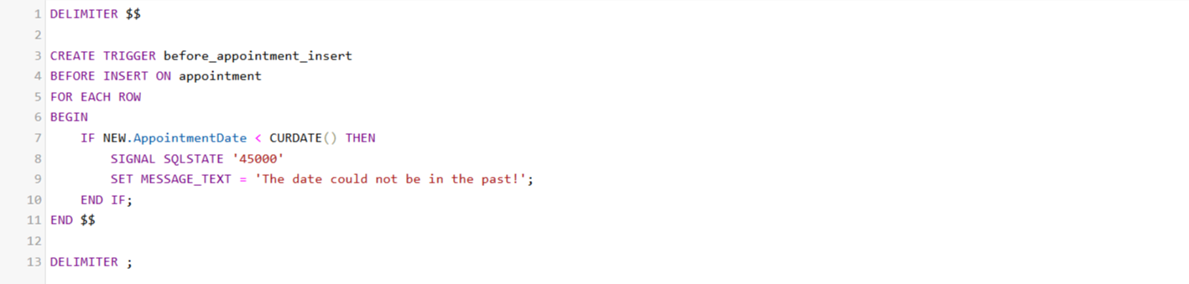

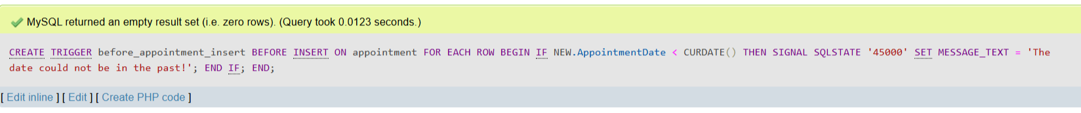

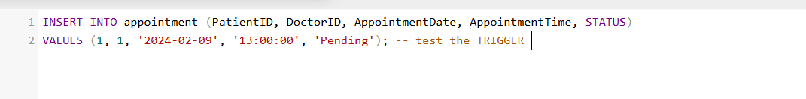

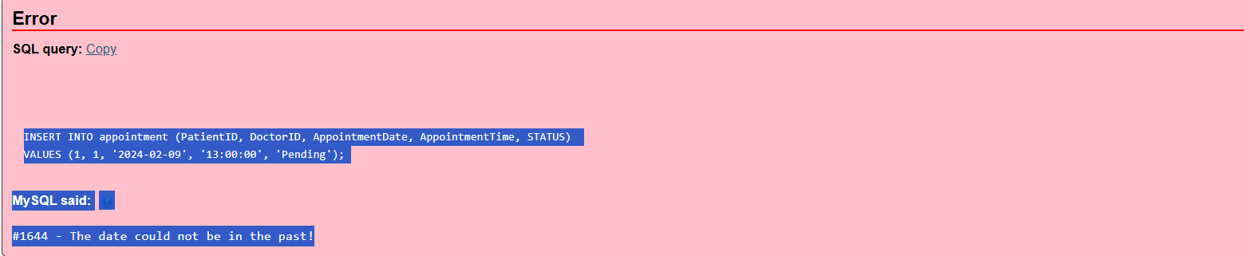

This trigger automatically prevents inserting a new appointment if the appointment date is set in the past.

Task 4 – Reflection (2 Marks)
Write a 300–500-word reflection on your experience while completing this project by
answering the following questions. Your responses should be clear, concise, and
supported with specific examples from your own work.
- Describe one specific challenge or obstacle you encountered during this project and explain in detail how you identified and resolved it.
- Explain why you chose your specific approach/method/model over at least one alternative you considered, and what tradeoffs informed that decision.
- If you used any AI tools during this project (e.g., ChatGPT, Claude, Copilot), disclose which tool(s), for what specific purpose (e.g., debugging, grammar checking, brainstorming), and how you verified or modified the output.
- What would you do differently if you were to redo this project with more time or resources?

The hardest issue regarding the current project we had to deal with is connected with the creation of database schema before writing SQL queries. In the beginning, it was difficult for us to understand how these entities are related and what to do with the supertype Employee and its subtypes. We carefully analyzed project requirements and some different models of the database and created ER diagram accordingly.

Then, we created tables using MySQL and checked them several
times. Whenever there were any issues, for example, incorrect references between
tables or wrong data samples, we fixed them and ran the script once again until
everything worked.
The structure of the database is connected with our choice to use Enhanced EntityRelationship (EER) model with specialization (ISA) instead of having four separates and unrelated tables.

This design was considered due to its convenience regarding the number of relations that it contains, as well as the duplication of common properties of employees like name, phone number, email, salary, and date of hiring.
Supertypes and subtypes helped to make the database more normalized and easier to maintain. The only disadvantage of such approach was
connected with the number of foreign keys and relations, but it was still a nice tradeoff.

Throughout this process, we made use of the AI tool called ChatGPT. We used it
for identifying the errors in the SQL syntax as well as for the grammatical
correctness of our report. We never used the output of the software without any
modification. We made changes in SQL queries, made the sample records
realistic, and ran every single SQL query in MySQL before submitting them.

We could have taken the project a step further with the help of some more time in
hand. We would have made it more realistic with the help of some more functions
like stored procedures, indexes, and triggers. Besides, we would have designed an
interface that was linked to the database for managing appointments, prescriptions,
and payments through a web application rather than the SQL queries alone. Overall,
this project has made us learn more about the designing of databases, SQL execution and the importance of testing different components of a database.

GitHub repository link:
https://github.com/abdulwahidAlQatari/Clinic-database

Deliverables
- Project Report (PDF) – System description, ER/EER diagram, relational schema, SQL code, screenshots, and reflection.
- SQL Script (.sql) – Complete SQL implementation of the project.
- GitHub Repository – Repository link with the complete project and commit history.
- Mid-Project Progress Report – Summary of progress, challenges, decisions, and team contributions.
- Project Artifacts
  - Live report document (with edit history): [link]
  - GitHub/GitLab repository (with commit history): [link]
  - Google Colab notebook (if applicable): [link]

